PF Task

Name:Sheryar Sher

Rollnum: 21p8027

Q1:

Code:

# this programme checks for vowels

letter = input("Enter Alphabet: ")

if letter in "a,e,i,o,u,A,E,I,O,U":

print(letter,"is a vowel")

else:

print(letter,'is a constant')

output:



Q2:

Code:

# this programme tell us about type of triangle

x = int(input('input lengths of the triangle sides:'))

y = int(input('input lengths of the triangle sides:'))

z = int(input('input lengths of the triangle sides:'))

if x == y == z:

print("equilateral triangle")

elif x == y or x==z or y==z:

print("isoscales triangle")

else:

print('scalene triangle')

output:

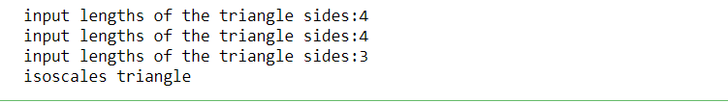

Q3:

Code:

# this programe simple mathmathical operations for us

num = int(input('enter a number: '))

num2 = int(input('enter second number: '))

operator = int(input('press 1 for add / press 2 for sub / press 3 for mult / press 4 for div:'))

if operator == 1:

print('sum of ',num, 'and', num2,'is:',num + num2)

elif operator == 2:

print('subtraction of ',num ,'and', num2,'is:',num - num2)

elif operator == 3:

print('product of ',num ,'and', num2,'is:',num * num2)

elif operator == 4:

print('division of ',num, 'and', num2,'is:',num / num2)

else:

print('press correct number')

output:

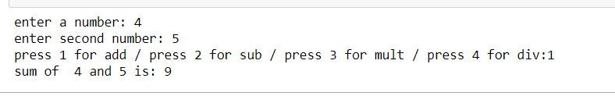

Q4:

Code:

# this programme give us the largest odd number

def largest_odd(x,y):

if x % 2 and y % 2 != 0:

print(max(x,y),"is greatest odd number")

elif x % 2 == 0 and y % 2 != 0:

print(y,'is greatest odd number')

elif x % 2 != 0 and y % 2 == 0:

print(x,'is greatest odd number')

else:

print("none of them are odd")

largest_odd(8,6)

output:



The End